Short-beaked common dolphin (Delphinus delphis) mortality.

The short-beaked common dolphin (Delphinus delphis) is one of the most abundant cetacean species in the eastern North Atlantic (SCANS-II, 2008). It is considered a single population since no evidence of genetic structuring has been found in the area (e.g. Murphy et al., 2013). Some life history parameters: sexual maturity, life expectancy and pregnancy rate have been derived from post-mortem data obtained from stranded and by-caught individuals. In addition to these, parameters such as mortality-at-age are unknown but needed to estimate population dynamics.

Natural mortality has been estimated for long-living species using several approaches (see Table 1), based on the longevity (Hoenig, 1983; Hewitt and Hoenig, 2005) and weight (Charnov, 1993).

Table 1: Mortality models for long-lived species. Based on the longevity (Hoenig, 1983; Hewitt and Hoenig, 2005) and weight (Charnov, 1993)

However, marine mammals are believed to show a different mortality rate according to age, suffering high mortality at young ages, followed by lower and constant mortality which increases again at older ages. For this reason, mortality rate in mammals has been usually approximated using life table methodology (i.e. Read et al., 2012; Pierce et al., 2013). A life table is a vector of age-specific survival or mortality rates, and represents an important tool for understanding the demography of populations (Stolen and Barlow, 2003). Survivorship and mortality can be inferred directly by following one or more cohorts through time, or indirectly from analysis of an age distribution of living individuals (Caughley, 1966; Barlow and Boveng, 1991) or from the age distribution of deaths (Caughley, 1966; Spinage, 1972).

Although widely used for terrestrial and some marine mammals (Spinage, 1972; Hewer, 1974; Marmontel, 1993), few mortality models based on life tables have been constructed for cetaceans (Olesiuk, 1990; Barlow and Boeng, 1991; Brault and Caswell, 1993; Barlow and Clapham, 1997; Stolen and Barlow, 2003) .

Using data from stranded animals we can construct life tables that, although they may have some restrictions, are often approximated well enough for practical purposes (Stolen and Barlow, 2003). Based on this assumption, we constructed a life table from data from stranded carcasses from Galician coast (Northwest Spain) collected by CEMMA (Coordinadora para o Estudio dos Mamíferos Mariños) from 1990 to 2010, and age-at-death data estimated by Fiona Read by counting the age layer groups present in the teeth gathered from the carcasses.

However, the possible biases arising from the use of stranding data should be taken into account. For example, not all carcasses might arrive at the coast, especially those of small/younger animals that could be more vulnerable to predation, more rapidly decomposed and/or have lower detection probability (Stolen and Barlow, 2003). For this reason, several models have been used to fit a smooth age-specific mortality function such an exponential model, general linear model (GLM) family Poisson, a second-degree polynomial and the Siler model (Siler, 1979), using a maximum likelihood method.

Strandings models

Four models were used to fit total mortality to the common dolphin stranding data (deads-at-age) obtained off the NW coast of the Iberian Peninsula. The fitted models were: an exponential model, a GLM family Poisson, a second-degree polynomial model, and the Siler model mentioned above. The first three models were fitted directly to the numbers of dead-at-age dolphins derived from the stranded animals that were aged. The Siler model was fitted using the mortality-at-age derived from a life table constructed using the stranding data. In all cases, the models were first run with all the available data and afterwords models were rerun after removing the younger age classes sequentially. Accordingly, each model was fitted to four data sets of different length (Figure 1).
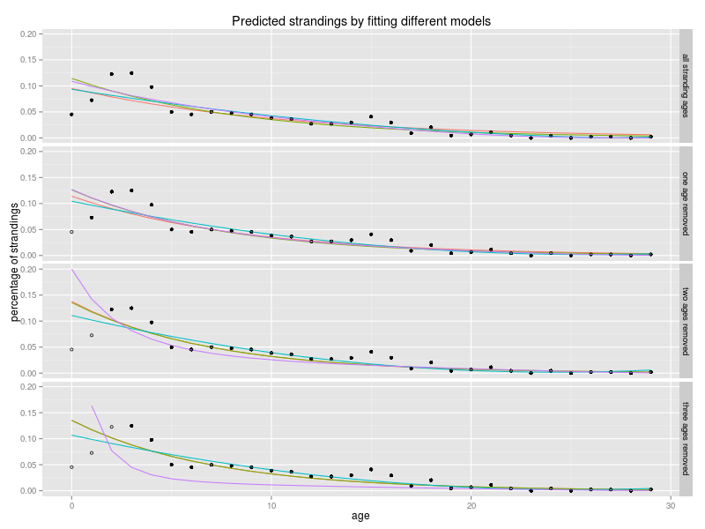
Figure 1: Predicted strandings applying different models: Exponential model (red), GLM family Poisson model (green), second-degree polynomial model (blue), and the Siler model (purple). Models fitted with all the available data and fitted after removing the younger age classes (none, one, two and three age classes). Total stranded dolphins used to fit the model (black dots) and stranded dolphins removed (circles).

It is worth noting that the Siler models show a slightly different pattern when compared with the other three models tested. Siler model is a three component competing-risk model for animal mortality, in which three addictive hazards are included: a negative exponential model dominant during the prematurity period; a constant hazard; and a positive exponential model, dominant during senescence. To fit the negative exponential model, ages 1 to 8 (immature animals) were included, rerunning the model after removing the younger age classes sequentially. Constant mortality corresponded to the mortality of the age 5, age at which mortality is lower. The positive exponential model for senescence animals was fitted using ages form 8 to 29. Age 8 was used to fit juvenile and senescence mortality because it is the age at which half the animals are mature. A good explanation of the three components and the contribution of each for the whole model can be visualized in Figure 2 for the model fitted with the data set where the first two ages were removed.
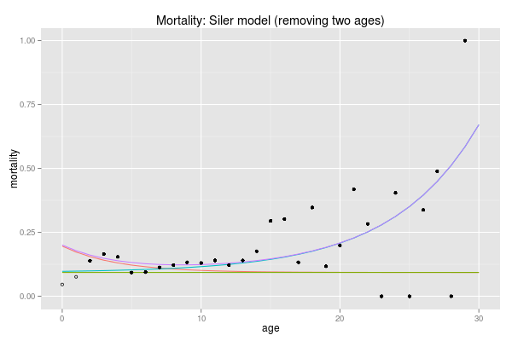
Figure 2: Mortality fitted with Siler competing-risk model. Siler mortality (Purple line), juvenile mortality (red line), constant mortality (green line), senescence mortality (blue line). Mortality-at-age from the raw data used to fit the model (dots), and mortality-at-age in the raw data do not used to fit the model (circles).

While the exponential and the GLM give similar fits throughout all age classes and for all data sets, the second-degree polynomial model overfits some values and gives unreal figures, mainly in the last age classes. Life tables were constructed for each model to estimate the mortality-at-age. In Figure 3, it can be appreciated that the predicted total mortality (Z) is quite similar for the exponential and GLM for the four different fits (by removing none, one, two and three of the first age classes) although mainly in the second and third cases. The second-degree polynomial shows a similar fit at the first ages to the others but a peculiar shape in the older age classes due to overfitting, and even, with the raw data set, negative values in abundance were obtained causing an unrealistic truncated line (Figure 3). The Siler model differs more from the other models at the earlier ages because it better captures the differences in these ages. The senescence mortality slope is more progressive than for the other models and, therefore, it is not needed a big increase at the end to achieve population balance. Nonetheless, the fit is not good with the raw data because the exponential model becomes positive instead of negative due to lack of strandings data in the first age classes and, therefore, very low values. That leads to an increase in the mortality associated with senescence and therefore an error in the model which supports the decision to remove the first ages.

Comparing the same model fitted with the different data sets as we can see in Figure 4, big differences become evident in older age classes with the second-degree polynomial model fit, as explained above. However, slight variations occur when different datasets are fitted with the GLM and exponential model. Furthermore, that differences are very small with the GLM fit, therefore we can conclude that differences in the pattern of strandings are very small in the case of GLM fit regardless of number of young age classes we use. However, we have already seen that the Siler model shows large differences in the earliest ages from the other models and between data sets. This is due to the low number of data used to fit the negative exponential model which fits the juvenile mortality. Discarding the raw data fit, when only one class is removed, the number of strandings shows a small increase followed by a decrease. This leads to the conclusion that there is still a lack of data in that age class and therefore, mortality will be underestimated. The opposite occurs in the latter case, where too many age classes have been removed, and the slope of the fit increases too rapidly with the mortality of the first age classes. For this reasons, the model where two age classes were removed seem to be the best and mortality of the first age classes appears reasonable. In any case, differences in the mortality in the first age classes seems high and could significantly affect to the population structure since in the first age classes is where the greater number of individuals are found.
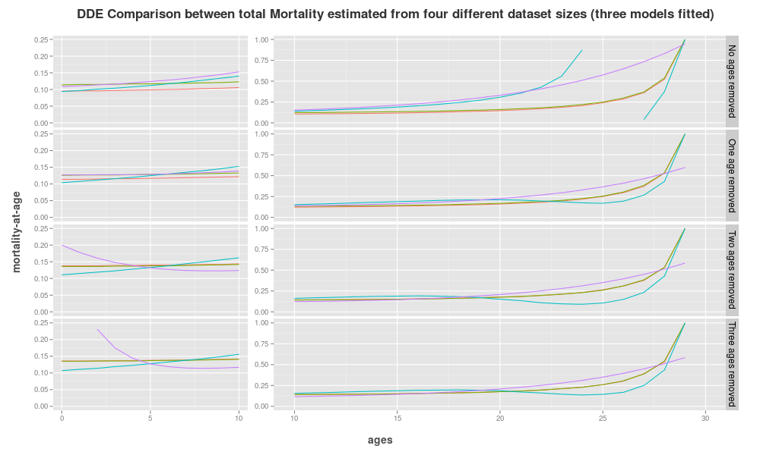
Figure 3: Predicted total mortality from four data sets of different sizes and four models and: Total mortality predicted from a life table constructed with an Exponential strandings model (red line), a GLM family Poisson (green line), a second-degree Polynomial model (blue line) and a Siler model (purple line). Each model was fitted to the total number of stranded animals for which age was available (No ages removed) and stranding numbers after removing the youngest age classes sequentially, 0 (One age removed), 0 to 1 (Two ages removed), 0 to 2 (Three ages removed).
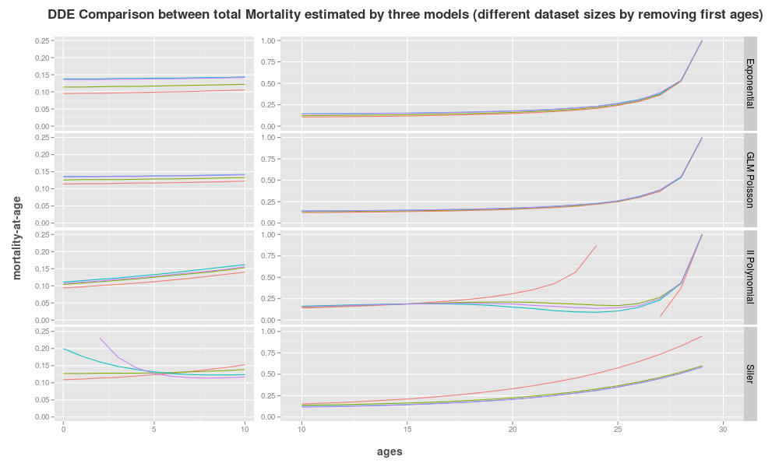
Figure 4: Predicted total mortality with four models and from four data sets of different sizes: Total mortality predicted from a life table constructed with an Exponential strandings model (Exponential), a GLM family Poisson (GLM Poisson), a second-degree polynomial model (II Polynomial) and a Siler model (Siler). model was fitted to the total number of stranded animals for which age was available (red line) and stranding numbers after removing the youngest age classes sequentially, 0 (green line), 0 to 1 (blue line) and 0 to 2 (purple line).
Life tables

Life tables were assembled for each model because, assuming a stable population, life tables allow the construction of a theoretical population structure with a corresponding abundance by age and calculate the survivorship and mortality-at-age. Choosing the model with two ages removed as the one that best fits our data, survivorship and mortality differences can be compared from life tables between the raw data and both the Exponential fit, the GLM and the Siler model (Table 2).

Table 2: Survivorship and mortality-at-age from the raw data and from the predicted data fitted with the data set with two ages removed: Survivorship (S) and mortality (M) both from the raw strandings data (lifeN) and from the strandings predicted with the Exponential model (lifeExp2), the GLM (lifeglmPois2), the Polynomial model (lifeIIPol2) and from the predicted mortality of the Siler model (lifeSiler2).

In figure 5 survivorship and mortality are graphically represented. Mortality-at-age for the raw data is highly variable specially specially for older ages. By fitting the models, these variations were smoothed. Differences between models can be observed in the youngest ages where the Siler model estimates higher mortalities corresponding to the immature hazards explained above. Then, adult Siler mortality is slightly less than in the GLM and exponential models, and in the older classes is higher, but not in the last ages where most dolphins have already died. However, polynomial model show different patterns although it may be due to overfitting. In addition, survivorship decreased faster in the GLM and exponential models than in the raw data, and even more when mortality was fitted with the Siler model. This suggest that the mortality of the earlier age classes is being underestimated when we use the raw data due to lack of animals in the stranding series at the youngest ages as mentioned. For this reason we propose to use a model to obtain a better fit to these age classes.

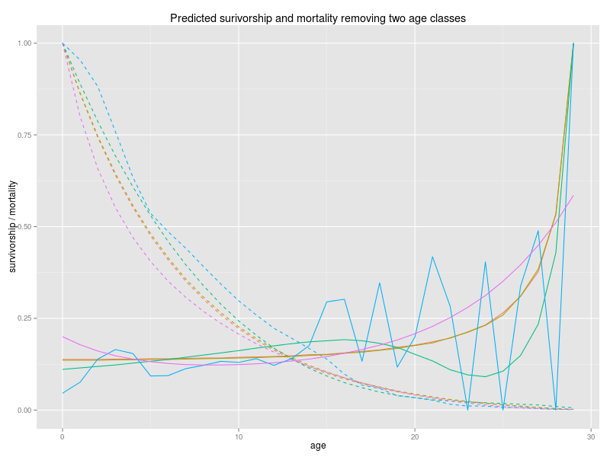
Figure 5: Survivorship and mortality for the data set with the youngest two age classes removed: Raw data survivorship curve (blue dashed line), raw data mortality curve (blue line), predicted exponential survivorship curve (red dashed line), predicted exponential mortality curve (red line), predicted GLM survivorship curve (brown dashed line), predicted GLM mortality curve (brown line), predicted Siler survivorship curve (purple dashed line), predicted Siler mortality curve (purple line).

Population structure

Once the life tables have been constructed, population structure can be calculated for an estimated population of 15000 dolphins living in the Iberian Peninsula (calculated as 4/5 of the area covered by Block W in the SCANS-II survey, SCANS-II, 2008) by multiplying the percentage of dolphins in each age class by the total population (Table 3). Since stable population is assumed and no density dependence or starvation is taken into consideration, the total abundance of the population does not affect the life table dynamics and therefore no other population estimates have been used.

Table 3: Population structure: Population structure with a total abundance of 15000 dolphins estimated from the total strandings data (lifeN), from the exponential model (lifeExp2), from the GLM (lifeglmPois2), from the polynomial (lifeIIPol2) and from the Siler model with the two first age classes removed (lifeSiler2).

Maturity ogives

Separate ogives for males and females were constructed to estimate the amount of mature females in our population. ...A binomial GLM (used for presence-absence data) was applied to the maturity (mature-inmature) data. Three anomalous data points (immature females older than 10 years) were removed from the dataset and a new female model was rerun without them. The A50 was calculated (the age at which half of the dolphins have achieved maturity). Therefore, two ogives were fitted for females, one with the anomalous data points mentioned above and the other without them. The male model did not converge and this may have been due to the scarcity of data available. The A50 were 9.5 and 8.6 for females with and without anomalous data respectively and 7.1 for males (Figure 6).
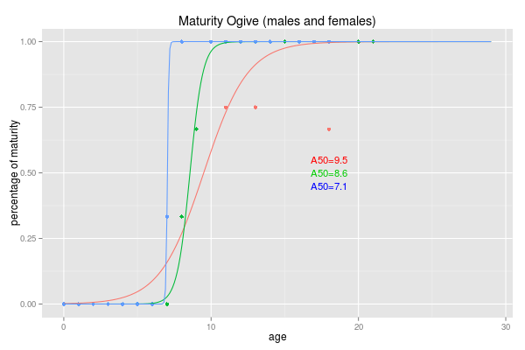
Figure 6: Maturity ogive (males and females). Males maturity ogive (red line), females maturity ogive with all data (blue line) and females maturity ogive where the three anomalous data points were removed (green line). A50 for the two models.

Three maturity vectors are shown in table 4. The table shows the percentage of mature males and females by age. The table also includes the percentage of mature females by age class once the three anomalous points have been removed.

Table 4: Maturity vectors. Percentage of mature males by age and for all females (all) and for the females after the three anomalous data points were removed (rm).

Since the corrected female maturity ogive will be used for the population model, 95% confidence limits for the A50, were derived by bootstrapping. A figure of 8.7 [8.0-9.1] was obtained. Although it is believed that the variability in the estimation of maturity will not have much influence on the population model, a sensitivity analysis will be performed to check its effect.

Recruitment

It is assumed that the number of males and females in our population is the same or very similar so, sex ratio may be 1:1 or close to it. Therefore, female abundance per age was obtained by dividing the number of dolphins of each age class by two. Multiplying this figure by the maturity vector allows the calculation for the total number of females. However, since we need the number of females which can give birth we remove the females at each age class that will die in the current year or move up the maturity vector 1 year and also remove the females of the last age as these dolphins will not give birth next year, assuming a gestation period of 1 year (Murphy, 2013). Furthermore, data must be divided by the pregnancy rate since not all the females will give birth each year. Pregnancy rate is an imprecise index about 25-33% (Murphy, 2013), thus we have calculated the number of births by applying three different pregnancy rates (25, 33 and 50%). Births estimated by each model are shown in table 5.

Table 5: Number of births. Calculated with three different pregnancy rates (25, 33 and 50%) from the total strandings data (lifeN), from the exponential model (lifeExp2), from the GLM (lifeglmPois2), from the polynomial (lifeIIPol2) and from the Siler model with the two first age classes removed (lifeSiler2).

By catch

The calculations of mortality we have described so far relate to total dolphin mortality in the area. However, as explained before, the estimated total mortality is too high to maintain a stable population. For this reason, we attempted to separate natural from fishing (by-catch) mortality in order to extrapolate the natural mortality value to the whole study area and apply different fishing mortalities to each area according to the fishing effort level at each zone.
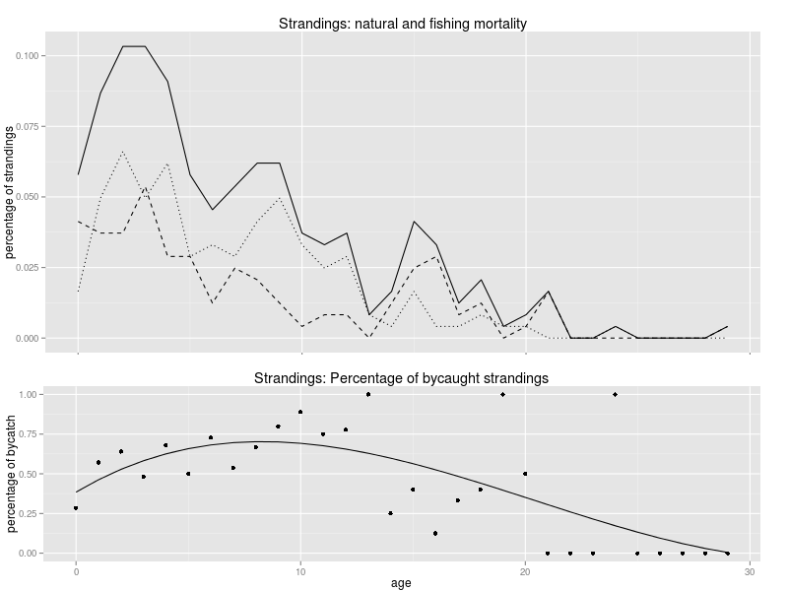
Figure 7: Natural and bycaught strandings: Percentage of total (solid line), unknown or non-bycaught (dashed line) and bycaught (dotted line) strandings by age [upper graph]. Percentage of bycaught dolphins in the total strandings (dots) and fitted model (solid line) [lower graph].

We first investigated fishing and natural mortality patterns. Bycaught dolphins were identified from the stranding data and the percentage of dolphins by-caught by age was calculated as before. This analysis showed higher bycatch mortalities at the younger and, also in older dolphins (Figure 7). To reduce total mortality in the exactly corresponding fraction was calculated a vector with the percentages of bycaught dolphins by age and applied over the total mortality for this region to obtain natural mortality. This vector proceeds from a third-degree polynomial model fitted to the percentage of the bycaught dolphins.

Sensitivity analysis

Differences between models are not very large, however only the Siler model capture the trend in juvenile mortality. This trend can vary considerably depending on the number of age classes used for adjustment. Based on this, the Siler model fitted after removing the youngest two age classes was considered the best fit and the one which made more sense biologically.

A sensitivity analysis to investigate the influence of the assumptions for juvenile mortality was carried out by varying 25% up and down the value of the intersection of the juvenile curve with the y axis. Note that only the slope of one component of the Siler model, the juvenile mortality, was modified while constant and senescence mortality were not altered. In Figure 8 these curves are graphically represented, red line represents original Siler model while dashed red lines represent slope variations.

Another important source of uncertainty is the one related to the percentage of bycaught dolphins. The analysis might be of particular relevance, since only dolphins with clear evidence of bycatch (e.g. net marks or mutilated fins) have been included in this category. Therefore, it is likely that the non-bycaught or other category could include some by-caught dolphins. Because of this, the percentage of bycatch mortality may be an underestimation and therefore, natural mortality will be overestimated.

As outlined in the bycatch section, a vector with the percentage of bycaught dolphins at each age was estimated using a cubic polynomial. Reducing total mortality-at-age in their respective percentage, natural mortality will result. Furthermore this percentage of bycatch for each age have been incremented and reduced by 25% to evaluate the effect of juvenile mortality on population dynamics. Consequently three different natural mortalities were calculated. The uncertainties in the adjustment of juvenile mortality was also examined for each of the calculated curves in the same way as for total mortality. In Figure 8 natural mortality and 25% of variation in its slope, obtained from the original bycatch percentages, is coloured in dark blue, and 25% of variation in the bycatch percentage in light blue.

The third uncertainty point is the pregnancy rate since small variations can greatly affect the recruitment and population stability, thus the number of annual births was calculated with three different pregnancy rates for each model. Population structure is needed for this calculation so, life tables for each model were performed, three for total mortality and nine for natural mortality. In addition to these, values of births for each model were also standardized by the abundance of its age 0, thereby, they can be compared among themselves.

In Table 6 number of births and their standardized values are presented, as well as the mortality-at-age and the population structure for each model. Mortalities-at-age were taken from the life tables and population structures were calculated with a total population of 15,000 dolphins (see above).

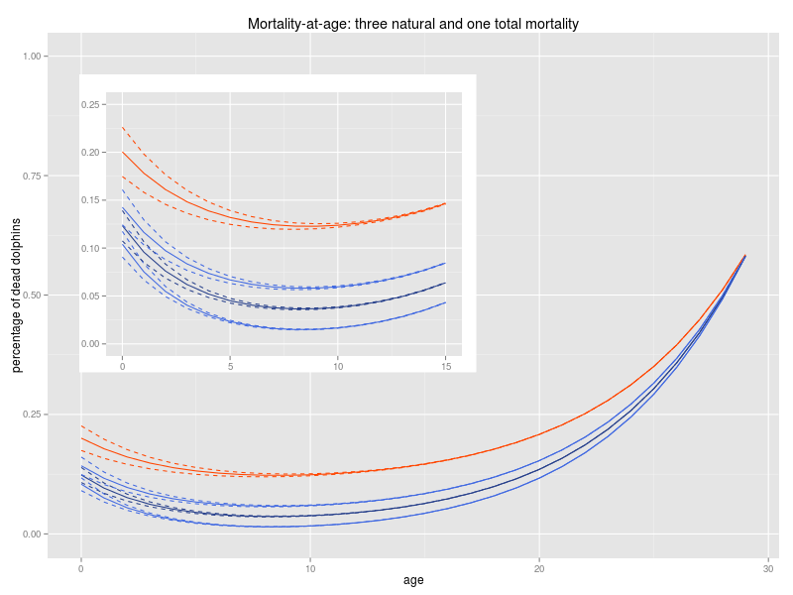
Figure 8: Three different vectors for total mortality and nine for natural mortality: Total mortality with an increment and reduction of 25% of its slope of the juvenile mortality (solid and dashed red lines). Natural mortality calculated by removing bycatch from the total mortality and 25% of variation in its slope (solid and dashed dark blue). Natural mortality calculated with an increment and reduction of 25% of the bycatch calculated for Galicia and 25% of variation in its slope (solid and dashed light blue).

If a stable population is assumed, the number of annual deaths must be the same as the number of births. The number of animals of age class 0 represents the annual recruitment for a stable population, therefore, if births are higher the population will grow and if animals are born the population will decrease. Since the distribution of the abundances between ages vary depending on the mortality level of each age, the total number of mature females will be different in each population modelled and therefore, the annual births. With the standardized value of births, we know what proportion of their respective age class 0 these births represent. Thus, the standardized value must be at least 100 to achieve the amount of births needed to keep the population stable, however, only a few values in our data satisfy this requirement.

The mortality in the three total mortality models for Galician dolphins is too high, with any slopes analysed, to keep the population stable. Abundance would therefore drastically decrease if this mortality were the same in the whole distribution area (see first columns in Table 6). Only 15% of the births needed to keep a stable population are achieved if we increase the original slope in 25% and a 25% of pregnancy rate is applied. The maximum percentage of births is reached by reducing 25% the slope and with a 50% of pregnancy rate, but even so, it would be only 38% of the amount needed to keep the population stable.

Table 6: Population structure, mortality-at-age, and number of births: All of this values calculated for three total mortalities (three slopes of juvenile mortality), nine natural mortalities (three levels of bycatch and three different slopes for juvenile mortality each one) and with three different pregnancy rates.

Of all the models tested, only the two with the lowest mortality rates could be feasible. These models correspond to the one calculated with the original bycatch data (animals with clear signs of bycatch) and the model where bycatch increases by 25%. These models correspond to that calculated from original bycatch and that calculated from the bycatch increased 25%. In the model where the original bycatch was reduced by 25% only one option would be possible to keep a stable population. With 50% of pregnancy rate the number of births would reach the amount needed to attain population stability (103%) but even could de insufficient considering that no fishing mortality is currently being applied. Furthermore, the natural mortality which was calculated with the original percentage of bycaught strandings might not be feasible since needed number of births are only achieved applying a pregnancy rate of 50%, much higher than the values reported in the literature.

The model that better satisfies the requirements to maintain stability in the population is the model in which the original bycatch estimate was increased by 25%. This supports the theory discussed above that the bycatch level could be underestimated. Therefore, natural mortality levels estimated by this model probably are the maximum amounts that this population can sustain since if the pregnancy rate would be 25% only the model with the slope reduced by 25% in the first ages would allow a stable population. If pregnancy rate would be 33% or 50% all models with the three different slopes would attain population stability. Even if there were no bycatches, population abundance will increase because births will range between 124%-135% and between 187%-202% respectively of the value needed to maintain a stable population. However, since bycatch is a known cause of mortality, these levels are needed to maintain a stable population.

Maximum mortality level

Construction of a theoretical stable population with some degree of catch was carried out on the basis of the natural mortality obtained from the model in which the original bycatch estimate was increased by 25%. A given value of fishing mortality was added to each age of the natural mortality as follows: natural mortality was extracted to the total mortality of the galician dolphins, accordingly, resulting mortality corresponded to the fishing mortality in Galicia. Then this mortality was again added to the natural mortality but previously reduced in a certain proportion. This proportion was calculated with the “optim” function of R and represents the maximum value of bycatch that the population can accept to keep the stability. Note that the proportion by which the fishing mortality was reduced is the same for all ages but the absolute number of each age is different since the proportion of bycatch in each age is different and the distribution is not the same as the natural mortality, as was explained in the correspond section. The same analysis was developed for the three pregnancy rates and the three slopes of mortality in the first ages.

Table 7: Rate at which the level of bycatch should be reduced to maintain a stable population: The bycatch calculated from the total mortality of galician dolphins should be reduced in the proportion as show below if a stability in the population is required. This proportion was calculated for the three total mortalities with different slopes in the first ages and for three different pregnnacy rates.

In figure 9 is shown the maximum mortality that the population can accept to keep it stable depending on whether the pregnancy rate is 25, 33 or 50%. For each pregnancy rate three curves were calculated corresponding to each of the three different total mortalities and natural mortalities, with different slopes in the first ages. Total and natural mortality is also displayed. For pregnancy rate of 25%, total mortality is almost the same of the natural mortality, therefore, no bycatch would be accepted in this population. With 33% of pregnancy rate, bycatch mus be reduced between 82.4 and 88.3% of the present value in Galicia, and between 58.3 and 66.5% for pregnancy rate of 50%. In either case bycatch should be reduced more than 50% of the present value. In table 6 is shown the proportion by which bycatch should be reduced, values higher than 100% indicates that no bycatch is allowed, and even, natural modality should be less than that used.

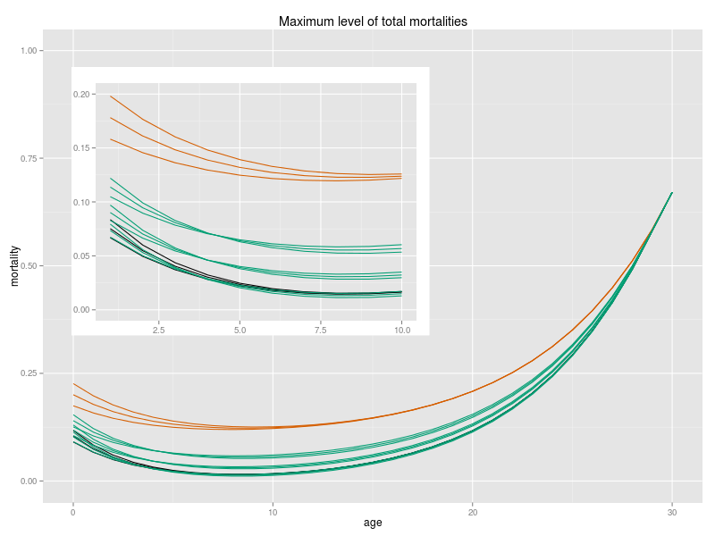
Figure 9: Maximum level of total mortality: Total mortality from Galicia fitted with three different slopes of the mortality of the first ages (red lines). Natural mortality obtained by subtracting the bycath from Galicia, assuming that it is 25% higher than the originally calculated, and fitted with three different slopes of the mortality of the first ages (dark lines). Total mortality accepted for the population to keep the stability calculated with three different pregnancy rates and fitted with three different slopes of the mortality of the first ages. Pregnancy rate of 50% (three upper green lines), pregnancy rate of 33% (three green lines in the middle), pregnancy rate of 25% (three lower green lines).

NOTE: For the Gadget model, total mortality I've used is that calculated with a pregnancy rate of 33% and without changing the slope of the mortality in the younger ages (slope * 1).

